Particle systems: they’re cool and we need and excuse to implement quicksort

# Out: Monday, May 14 Due: Monday, May 21, 11:59 PM

# Overview

In this assignment, you will implement depth-sorting of sprites for transparent rendering in a particle system. We’ll explain what that means shortly, but short version is that you’ll be implementing insertion sort and quicksort in a real application and use metering tools to measure their empirical average- and worst-case performance. As before, we’ve also provided a set of automated tests to ensure that your sort algorithm is properly sorting.

# Particle System Overview

Particle systems are a type of very simple physics simulation used in computer graphics. They were first used commercially by the Industrial Light and Magic to render the “genesis effect” scene from the film *Star Trek 2: The Wrath of Khan*. They are commonly used to produce effects such as explosions, clouds, rain or snow, hair, or realistic fluid flow.

A particle system animates a large number of very simple “particles” which obey very simple laws of motion, typically not including any physical interactions between the particles themselves. For the Happy Fun Blob game, the particles obey basic physics (i.e. they have position and momentum), and they are attracted to the amoeba. To simulate the appearance of the amoeba being in a fluid that it displaces as it moves, the particles nearby the amoeba are also accelerated in the direction of the amoeba’s motion. In a perfect world, the particles would also collide realistically with the different obstacles in the world, however, that would be too computationally expensive given the number of particles and obstacles, so the particles currently pass freely through objects. It’s simple, but it’s enough to provide some simple, engaging motion.

Particle systems are typically rendered (drawn on the screen) by drawing simple 2D images called *sprites* in the appropriate location, rather than drawing a full triangle mesh, as is done for true 3D objects. This allows a relatively realistic looking object to be drawn using only one or two triangles, rather than the tens (or thousands) that might otherwise be necessary.

## The painter’s algorithm

Particularly for applications such as smoke or flame, these sprites are typically drawn using *transparency*. This means that when we draw a sprite in a particular location, its pixel values don’t simply replace the existing pixel values in that location, but instead are composited with the image already drawn in that location, so that the sprite acts as both as a new image, and as a filter through which the previous image is viewed. Complex effects can be achieved by changing the degree of transparency or opacity of different parts of the sprite.

The problem here comes when several particles might potentially be drawn in the same location of the screen. Because of the nature of the compositing, the final pixel color achieved depends on the order in which the sprites are drawn. To properly render the particles, we must use the *painter’s algorithm*: objects are drawn back-to-front: with the objects farthest from the camera being drawn first, and then the nearer objects being drawn on top of the farther ones, then the next farthest ones, and so on. This involves sorting the particles by their depth (distance from the simulated camera) so that they can be rendered back to front.

# Depth sorting

We’ve implemented the particle system for you. The basic objects are already defined, along with the physics simulation and the rendering code. All the code you need to deal with is in the file ParticleSystem.cs. The important classes are Particle, which not surprisingly represents an individual particle, and ParticleSystem, which represents the whole particle cloud and performs the physics updates and rendering. You’ll be modifying code in the ParticleSystem.

Although you should feel encouraged to read the rest of the code, the only thing you really need to know about the Particle data type is that it has a depth field, which gives its distance from the camera. The main field you will care about in ParticleSystem are particles, which is an array of all the particles.

All you need to do is to fill in the code for the procedures InsertionDepthSort(), and QuickSortDepthSort(). These procedures should sort the particles in the particles array by their depth fields. You can get the pseudocode for these procedures from either book or from the lecture slides. However, note that:

* The pseudocode for lecture slides assumes you’re sorting on the values of the elements themselves (so you say array[i]<array[j]), whereas in this case, you’ll be sorting on the values of their depth fields (so you say particles[i].depth < particles[j].depth).
* When swapping elements of an array (e.g. for quicksort), you can do it by saying (assuming we want to swap element i with element j):

temp = array[i];  
array[i] = array[j];  
array[j] = temp;

Your initial inclination would be to just say:

array[i] = array[j];  
array[j] = array[i];

However, this won’t work because the first line would erase the original value of array[i] before the second line can copy it into array[j].

# Getting started

This is a modified version of the last assignment. To get started:

* Unzip the code from the assignment.
* Copy the BSPTree.cs, ListDictionary.cs, and SyntaxTree.cs files from your previous assignments into the HappyFunBlob subdirectory.
* Open up the HappyFunBlob solution file
* In the HappyFunBlob project, open the ParticleSystem.cs file.

# Implementing the sorts

Fill in the code for the methods InsertionDepthSort() and QuicksortDepthSort() inside the ParticleSystem class. The methods are present in the class, but are currently blank. You can test your methods by running the test project, which will run both your insertion sort and quicksort and check that the resulting particle system is properly depth sorted.

For the quicksort routine, you will need to have some way of choosing the pivot element. Normally, you would most likely use randomized quicksort, in which pivot elements are chosen randomly. However, picking a random number can be relatively slow unless specifically optimized to run fast, and using the built-in .NET random-number generator actually slowed my implementation of quicksort down by a factor of 3. Given that the particles will usually be *mostly sorted* already (because the particles move relatively little from frame to frame of the animation), you will probably do fine by always choosing a pivot element in the middle of the range being sorted, that is, by choosing (start+end)/2 as the position of the pivot. You should feel free to experiment with other pivot choices, however, you are not required to do so as part of this assignment.

# Measuring Performance

Once you’ve debugged your sort algorithms, find the method DepthSort() in the ParticleSystem class, and modify it to use the InsertionSortDepthSort.

Now run the game and press the “P” key to bring up the performance profiler. You should see something like this:

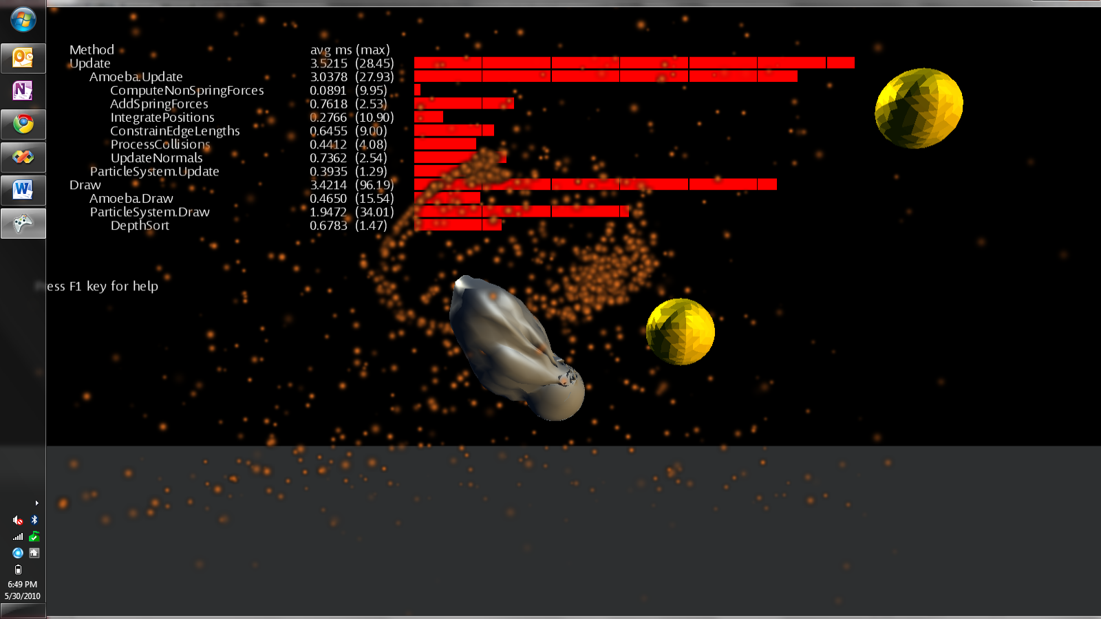

Each line of the display gives the execution performance of a different part of the system. The last line gives the performance of the depth sorting. The first number gives the number of milliseconds it took to sort all 3,000 particles, averaged over every update since the game was started. The number next to it (in parentheses) gives the maximum time it took to do the depth sort, again across all updates. The bar graph next to it shows the execution time of the most recent update; each segment of the graph represents 500 microseconds (i.e. half a millisecond). The degree to which the performance of the sort varies from frame to frame will be reflected in the degree to which the bar graph “wiggles” (high variability) or is steady (low variability). You can also reset the maximum execution time by pressing the “R” key.

Try playing the game and seeing to whether the performance of the sort algorithm is consistent, or varies under different conditions. Try rotating the viewpoint using the left- and right-arrow keys. This has the effect of changing the depths of all the particles at once, thereby reducing the degree to which the particles start out “mostly sorted” at the beginning of a frame.

Record the average and maximum execution times using the insertion sort in the table below. Now change the code in DepthSort() to use QuicksortDepthSort() instead, and try running the game and examining the timing data again. Again, record the average and maximum execution times. Which sort is faster? Normally, quicksort should stomp insertion sort, however, this is an application where we start each new sort with the particles “mostly” sorted from the previous sort, so you may find that insertion sort works well, at least part of the time. One the other hand, insertion sort may break down seriously if large numbers of particles are changing their depth orderings from frame to frame.

# Table of measured performance data

Fill in the table below with your measured execution times

|  |  |  |
| --- | --- | --- |
|  | Average ms | Max ms |
| Insertion sort |  |  |
| Quicksort |  |  |

# Turning it in

First, fill in the table of performance data above and save the file. Then, as before, to turn the assignment in, you should:

* Choose “Clean solution” from the Build menu in Visual Studio. This will remove binary files and bring your directory down to a manageable size.
* Exit Visual Studio
* Make sure you have your updated copy of this file with performance data in the directory with your code.
* Make a ZIP file of the directory. Please use ZIP format, not RAR, tgz, or other formats.
* Upload the zip file to blackboard.